Limmud Torah Genesis 4
Standard 6 Reading of Cain & Abel
Presented by: Aviva Silverman
TEXT: Genesis 4:1-16 CLASS: 7th – 9th Grades

STANDARD 6:

Students will develop an appreciation for the sacredness of the TaNaKH as the primary record of the meeting between God and the people of Israel and as an essential text through which Jews continue to grapple with theological, spiritual and existential questions.

BENCHMARKS:

6.15 Grapples with both the inspiring and the troubling aspects of the idea that God “speaks”.

6.16 Analyzes how various human/divine dialogues shed light on the divine/human relationship.

(See also: 1.10f Distinguishes between narrative, dialogue and inner quotations.)

UNWRAPPING:

TO KNOW TO DO SPECIFIC CONTENT

Narrative  Basic plot line | Sequence events  Retell the story | Genesis 4:1-16  Focus on 3 sections of dialogue:  Verses 3-7; 9-12; 13-16
What are and what is purpose of prooftexts (citations) | Support own ideas with examples from the text | Use citations and supports only from this selection (i.e. setting aside prior knowledge)
6.15 Grapples with both the inspiring and the troubling aspects of the idea that God “speaks”.

In the TaNaKH God ‘dialogues’ or interacts with the characters in many different (and to us unknown) ways | Identify and discuss the ways in which God dialogues/interacts with the characters | God speaks, God accepts and rejects the offerings, God asks questions, God punishes Cain, etc.
There are various motivations God may have in “speaking” to the characters in TaNaKH | Describe the written and possible unwritten actions and feelings of the characters during or as a result of the interaction with God  Posit God’s motivation for the interaction and defend position taken | Open-ended, but must have some textual support
God “speaking” in TaNaKH invites the reader to engage in personal interpretation | Demonstrate ability to grapple with the notion that God “speaks” by offering personal insights | Open-ended, but must have some textual support
6.16 Analyzes how various human/divine dialogues shed light on the divine/human relationship.

Human/divine dialogues in the TaNaKH serve a greater purpose (i.e. beyond the simple narrative) | Discuss and analyze the possible reasons for the human/divine dialogue  Speculate as to what this dialogue teaches (ie what purpose/s are served) | Possible human motivations for the offerings; possible responses by God; general tone of the dialogues; God’s response/s to Cain’s offering; to the murder of Abel; ways in which God metes out the punishment; dialogue about the punishment between Cain and God, etc.
Human/divine dialogues in the TaNaKH can inform our beliefs and values | Describe situations from the TaNaKH which shed light on the divine/human relationship  Discuss and analyze how those dialogues teach us about the divine/human relationship | Situations include: how we deal with rejection; our thoughts on murder; what does it mean to live with God’s mark/punishment forever, etc. in terms of what our relationship is with God.
Human/divine dialogues in the TaNaKH can inform our understanding of our own relationships | Utilize appropriate and varied words/phrases to describe relationships | Eg: The relationship is a loving, threatening, fearful, comfortable…one because…

BIG IDEAS:
The manner in which God “speaks” teaches us valuable lessons.
God cares about us even if God disapproves of our actions.

ESSENTIAL QUESTIONS:
What is the “balance of power” in our relationship with God?
How does a balance of power manifest in our own relationships with other people?
How do we know if God is pleased with our behaviour?

ENGAGING SCENARIO AND PERFORMANCE ASSESSMENT:

You are a comic book publisher and have just received the written script of Genesis 4. There is, so far, no art and no layout. Before you hire the artist/illustrator you will need to know how s/he will understand and depict the events in this chapter of TaNaKH. This is the written interview that will help you hire the best person.

TASK 1:
Draw a ‘storyboard’ of the 3 dialogue passages between God and Cain. Using emoticons (class set or your own) outline what you think Cain’s sequence of emotions was during each selection of dialogue. Write a 2-3 sentence explanation of each of your sequences. In the explanation please quote words from the text, where applicable, or indicate which verse/s support your emoticon choices.

Checklist:
___There are 3 separate submissions, one for each segment of dialogue.
___Each page includes 3-5 emoticons, in sequence.
___Explanation is written in full sentences.
___Textual support (quotes or verse number) is included throughout.

TASK 2a:

Choose any 2 of the 3 selections of dialogue and comment on what was taking place. Please address issues such as:
- Who speaks more than the other?
- Who asks questions of the other?
- What purpose/s do you think the questions serve?
- What are the responses to the questions?
- How might it feel to be spoken to in that/those way/s?
- Was this an effective conversation? Why or why not?

2b:
Discuss what you might infer about the relationship between Cain and God using this format: “In verses ______, I think the relationship is ____ because _____.”

Checklist:
___In paragraph OR point form, all the questions from above are addressed.
___The conclusion inference follows the format above (2b).
___The task is done twice.

TASK 3:

What tips can you learn from these dialogues that could help guide you in conversations with others?
Re-write the dialogue of ONE of the sections in a way that:
- evens out the balance in Cain’s and God’s relationship, AND
- would leave both of them satisfied with the resolution.
Begin with the opening line of the dialogue from the text:

למה חרה לך ולמה נפלו פניך. “Why are you distressed and why is your face fallen?”

OR
אי הבל אחיך. “Where is your brother Hevel?”

OR
גדול עוני מנשוא. “My punishment is too great to bear!”

Continue the conversation with at least 6 more speeches of dialogue (you may use more quotes from the text if you like, but you do not have to).
After completing your dialogue, copy your concluding comments for both Cain and God on the comic panel provided. You may add to the comic if you like.

Checklist:
___I began with one of the quotes from the text.
___I created at least 6 more dialogue speeches (at least 3 for Cain, at least 3 for God).
___The conversation concludes with a feeling of mutual resolution.
___I copied the last 2 dialogue speeches on to the comic panel.
___I indicated on the comic who is speaking.

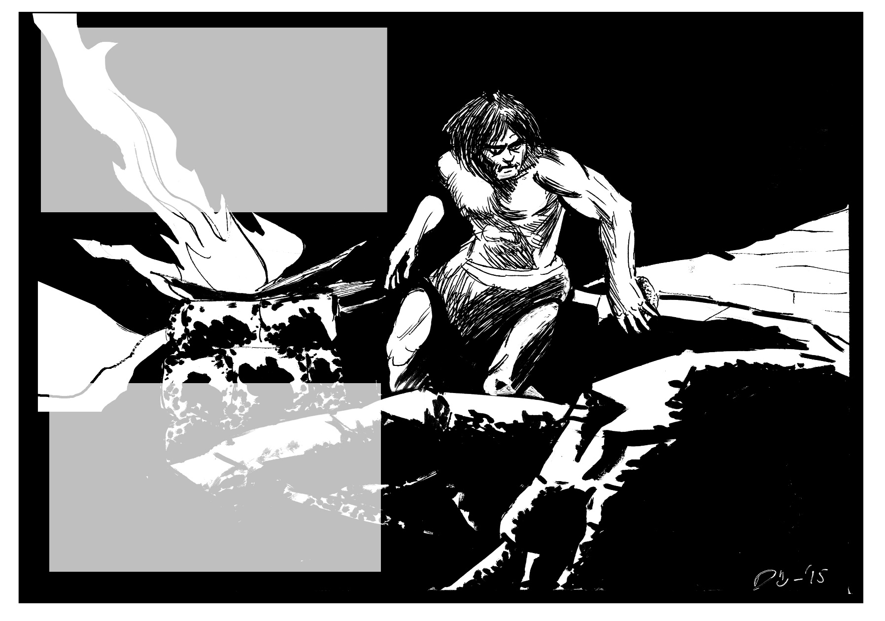

SAMPLE LESSON:

In hevruta please re-read the text quickly, noting the following sections of dialogue:

I. Verses 3-7 (after God’s rejection of the offering);
II. Verses 9-12 (after the murder of Abel);
III. Verses 13-16 (after Cain hears his punishment)

As you read these three segments, please think about the relationship between God and Cain.

In your group, with your assigned passage, discuss the following:
a) How does the dialogue take place (i.e., who speaks when, who responds to whom and how, etc.)?
b) What adjectives would you use to describe how God and/or Cain are feeling during this dialogue/conversation?
c) How do you feel about what Cain did/said in your section?
d) How do you feel about what God did/said in your section?
e) What might you learn about your own feelings about God based on this one interaction in the TaNaKH?

- Group Work. Using 3-5 emoticons, (samples appear on next page or create your own) outline what you think Cain’s sequence of emotions were during your selection of dialogue. (i.e. what is his mood at the beginning / middle / end of this section?) Use textual support for your choices if possible.
Be prepared to report this back to the large group.

- Individual Work. How does this one piece of text make you feel about God? Choose one emoticon and write one sentence below explaining your choice.

Sentence:
Emoticon:

http://www.google.ca/imgres?imgurl=http://www.clker.com/cliparts/2/G/D/B/D/c/blank-smiley-md.png&imgrefurl=http://boards.dallascowboys.com/topic/48991-dont-watch-the-draft-for-the-cowboys/&h=300&w=300&tbnid=vWrnLsnRFi-EuM:&zoom=1&docid=7fxmgyRZ5_BJ1M&ei=MOWWVaO4D5SXoQS3oazADw&tbm=isch&ved=0CB8QMygDMAM

